**Experiment No: 9**

**Name: Rajashri Jaywant Patil**

**Title: PL/SQL programs on factorial numbers and prime number.**

**1) The Program of factorial of a number in PL/SQL.**

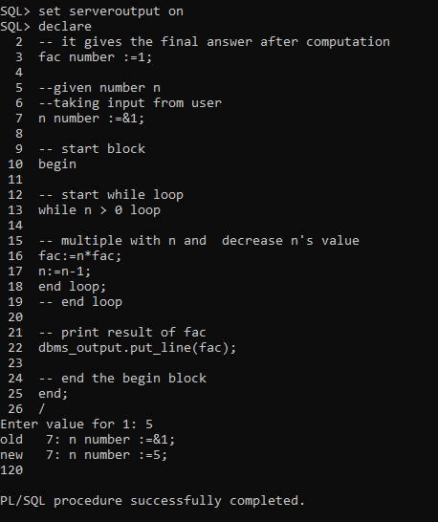

**2) The Program of Prime number in PL/SQL.**

